Analysing connectivity between physical dimensions and Y parameters of CRDN for wideband applications

Harsh Singh  
*Department of Electronics and Communication*  
*IIIT Naya Raipur*Naya Raipur, India  
harshs17101@iiitnr.edu.in

***Abstract*—** a new approach for isolating two adjacently placed coupled antenna is proposed in this paper. The technique uses coupled resonator decoupling network to nullify the effect of coupling between two antennas. Placing CRDN in between the antennas gives rise to different couplings in opposite direction of what previously bare antennas were possessing. Construction and design of CRDN is presented based on the admittance parameter which has been further converted into form of coupling matrix through rational function and analytical procedure involving simple mathematics. A clear relation is depicted in elements of the coupling matrix and physical dimension of resonators. The comparative results obtained through experiments and simulation for different designs proves electrical parameters are relatable with physical dimensions of CRDN. Proposed approach presents a way to apply it for asymmetrical antennas and MIMO systems.

***Keywords—CRDN, Admittance parameters, Coupling Matrix, electrical parameters, MIMO***

# Introduction

Mutual coupling between antennas is a popular unwanted effect, which reduces the performance of antenna arrays. Isolating these antennas has been a popular research topic among the researchers. Both the industry people and academicians have paid significant attention to rectify this problem. If talking in general then it can be said that coupling between antennas is unexpectedly different for both receiver antenna and transmitter antenna**.** Broadband  
transmitting and receiving antenna arrays have become essential in a high end wireless communication system. When multi antenna structure is planned inside mobile terminal, the antennas have to be placed in very compact space which brings high mutual coupling between the elements. Additionally this mutual coupling wastes a large portion of power fed into coupling from one port to another port rather than radiating the same power in free space. Various schemes of isolation have been proposed. The most used one are described.

## The space, polarization and angle diversity scheme

The simplest method to isolate two antennas is to increase the electrical distance between them [2] [3] [4]. When the angular speed of the channel completes the full sphere, the additional phase difference of two antennas will optimally de-correlate the incoming signal. Although in general three dimensional angular spread is rarely implemented. It is observed in inverted-F and inverted-L which are commonly used in mobile terminals that an increment in inter resonator distance results in weak isolation [5] [6]. By exciting the electric and magnetic mode on body, polarization diversity is achieved. In spite of getting advantage of this scheme motor, camera and battery’s effect on orthogonality of two antennas can’t be neglected. Due to this it is practically not implementable in mobile terminals.

## Eign-mode decomposition scheme

In the 1970’s, Andersen [7] suggested an essential condition for no coupling between antennas and proved it by inserting a part of transmission-line between the coupled antenna ports. The constraint is that the antenna spacing has to be kept at fixed values. A lumped element connected with the coupled antennas can also get a fixed level of isolation [8], [9]. Such decoupling techniques can be considered as a decoupling network of zeroth-order with relatively narrow decoupling bandwidth, which results in high sensitivity to the surroundings of the antennas in touch such as human hands.

## Coupled Resonator decoupling network(CRDN)

This technique introduces both sequential and cross coupling for a wideband decoupling performance .Compared to already existing schemes the presented scheme is having following special features: 1) it produces higher order isolation solution; 2) It provides a tradeoff between decoupling bandwidth and degree of isolation; 3) It is easily implemented in multiple antenna system[10]; 4) Currently available filter design techniques are used in realization. The synthesis and realization part of CRDN begins from finding matching and decoupling conditions. In this paper CRDN is realized using micro strip resonator. It can also be realized from low temperature co-fired ceramics and silicon based integrated passive devices.

# Synthesis and Design of CRDN

## Condition for decoupling and matching

For the second order system it is assumed that a pair of coupled antenna is described with admittance matrix (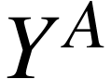). The decoupling network comprising two microstrip resonators in series which basically form CRDN is connected parallel to this coupled antennas.The entries in admittance matrix for CRDN (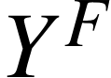) consist only purely imaginary values. After combining antennas with CRDN the final admittance matrix will be the sum of both the admittance matrix.

|  |  |
| --- | --- |
| <math xmlns="http://www.w3.org/1998/Math/MathML"><mi>Y</mi><mo>&#xA0;</mo><mo>&#xA0;</mo><mo>=</mo><mo>&#xA0;</mo><mfenced open="[" close="]"><mtable><mtr><mtd><msub><mi>Y</mi><mn>11</mn></msub></mtd><mtd><msub><mi>Y</mi><mn>12</mn></msub></mtd></mtr><mtr><mtd><msub><mi>Y</mi><mn>21</mn></msub></mtd><mtd><msub><mi>Y</mi><mn>22</mn></msub></mtd></mtr></mtable></mfenced><mo>&#xA0;</mo><mo>=</mo><mo>&#xA0;</mo><mfenced open="|" close="|"><mtable><mtr><mtd><msubsup><mi>Y</mi><mn>11</mn><mi>A</mi></msubsup><mo>&#xA0;</mo><mo>+</mo><mo>&#xA0;</mo><msubsup><mi>Y</mi><mn>11</mn><mi>F</mi></msubsup></mtd><mtd><msubsup><mi>Y</mi><mn>12</mn><mi>A</mi></msubsup><mo>&#xA0;</mo><mo>+</mo><mo>&#xA0;</mo><msubsup><mi>Y</mi><mn>12</mn><mi>F</mi></msubsup></mtd></mtr><mtr><mtd><msubsup><mi>Y</mi><mn>21</mn><mi>A</mi></msubsup><mo>&#xA0;</mo><mo>+</mo><mo>&#xA0;</mo><msubsup><mi>Y</mi><mn>21</mn><mi>F</mi></msubsup></mtd><mtd><msubsup><mi>Y</mi><mn>22</mn><mi>A</mi></msubsup><mo>&#xA0;</mo><mo>+</mo><mo>&#xA0;</mo><msubsup><mi>Y</mi><mn>22</mn><mi>F</mi></msubsup></mtd></mtr></mtable></mfenced></math> | ( 1) |

Decoupling Condition is taken as described in the [1].



Matching Condition is obtained as described in the [1].



## Synthesis of decoupling network

Coupling matrix terminology which is actually built for designing filters, can also be applied for realizing CRDN.

The complete process starts by constructing rational function for admittance values. For a second order CRDN without zeros the mutual admittance can be expressed as

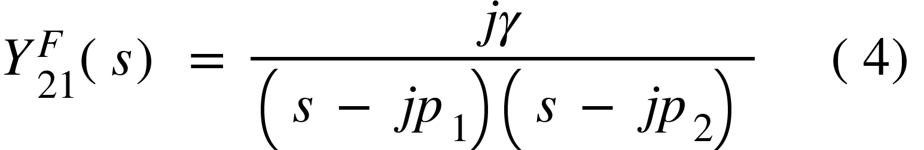

Self coupling can be represented from [1].

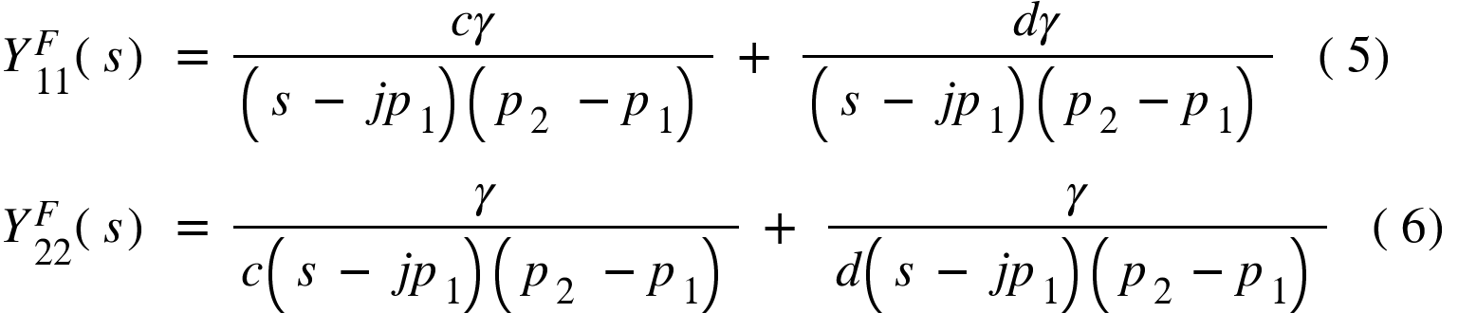

where c, d, ᵧ, p₁, p₂ are constants. As it is

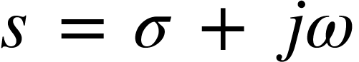 (7)

we can always analyse the function in imaginary axis[1].

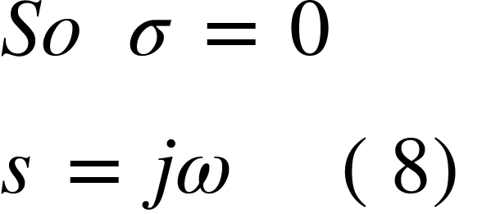

For a symmetrical network c = d = 1 and -p₁ = p₂ = p.After putting equation 8 into equation 5, 6, 4 and then putting equation 5 and 6 in equation 3 and equation 4 in equation 2 following equation are obtained by combining it with the conditions for a symmetrical network.

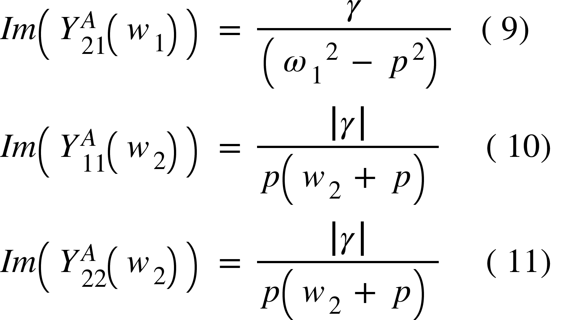

where w₁ and w₂ are frequencies related to wideband of antennas. After manipulating equation 9 with equation 10 or equation 11 following polynomial is obtained by which we can calculate the value of p and value of ᵧ.



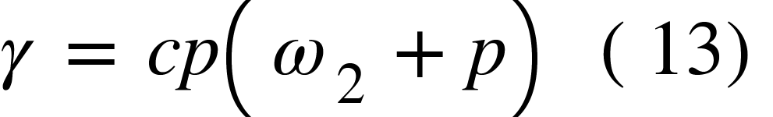

For a symmetrical network coupling elements are given from [1].

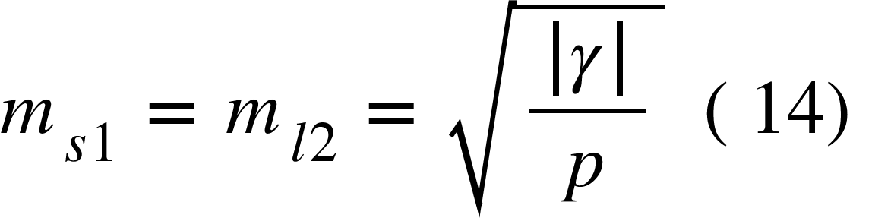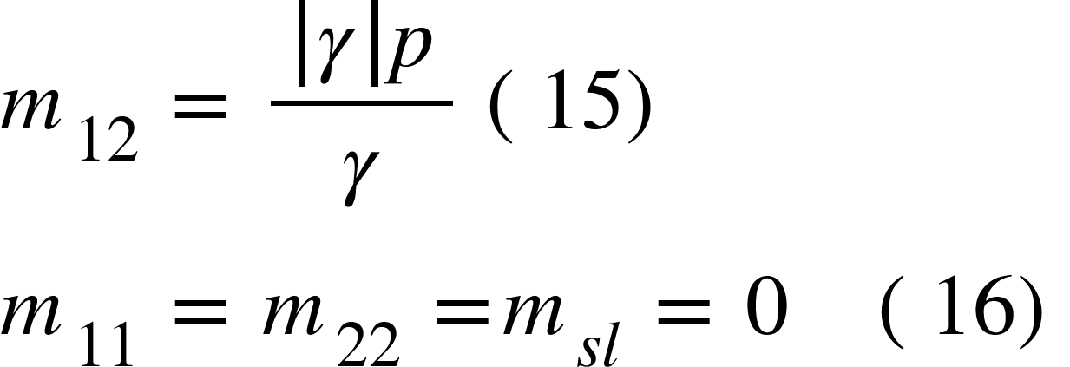

## Designs used in simulations

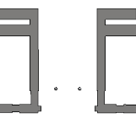

**(a)**

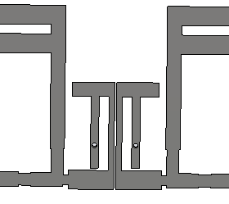

**(b)**

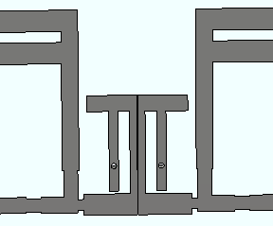

**(c)**

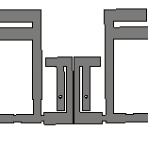

**(d)**

Fig. 1. Pairs of antennas for (a) Without CRDN (b)With CRDN having inter resonator distance 0.4 mm and inner resonator distance 1.64 mm (c) With CRDN having inter resonator distance 0.2 mm and inner resonator distance 1.64 mm (d) With CRDN having inter resonator distance 0.4 mm and inner resonator distance as 0.41 mm.

## Results obtained for all the design

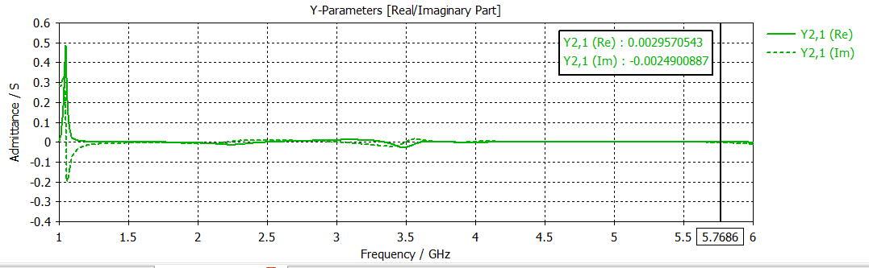

(a) 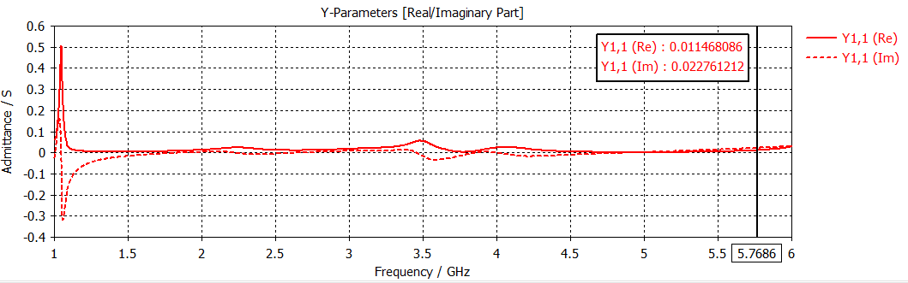

(b)

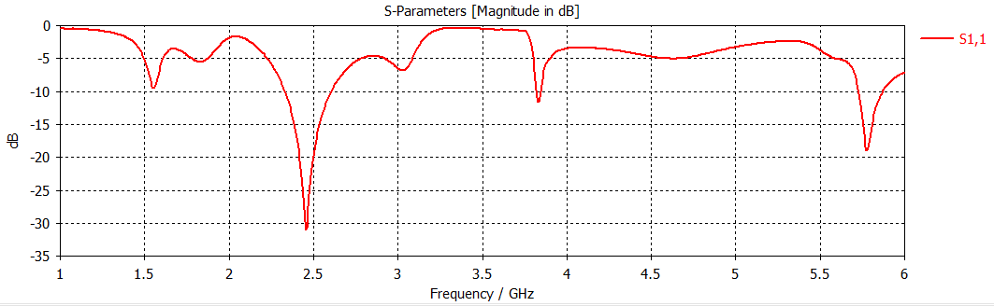

(c)

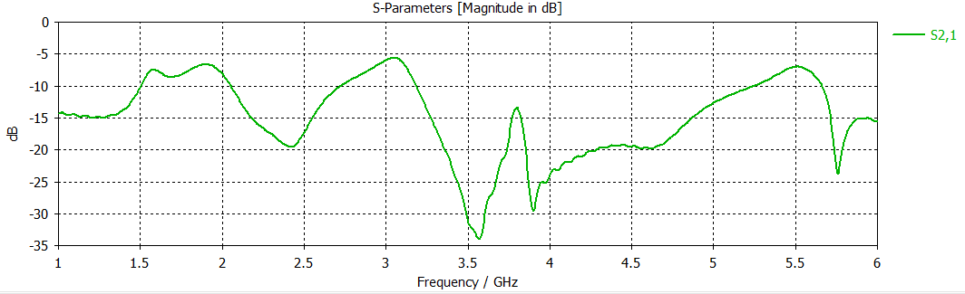

(d)

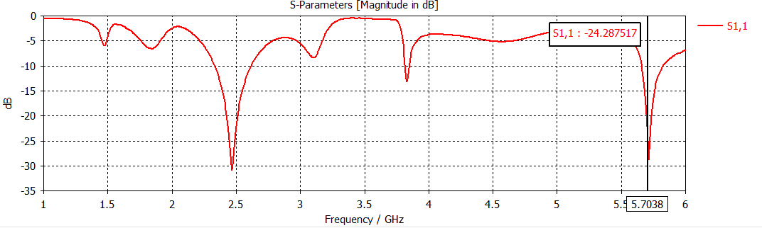

(e)

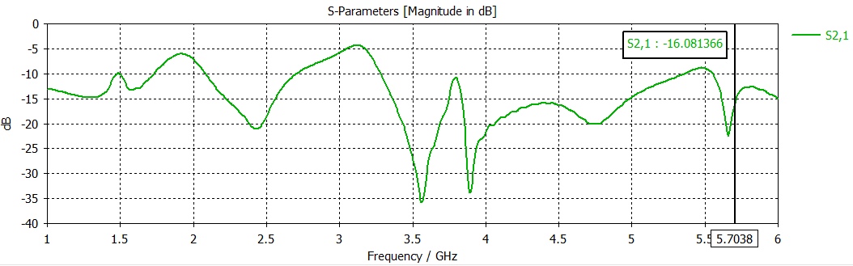

(f)

## 

(g)

## 

(h)

Fig. 2. (a) and (b) Y parameters variation for pair of antennas without CRDN, (c) and (d) s parameter variation for design in Fig. 1. (b), (e) and (f) s parameter variation for design in Fig. 1. (c), (g) and (h) for design in Fig. 1. (d).

## F. Comparing results obtained through all designs

Using results obtained in ⅱ (D) and analytical procedure described in ⅱ (B) a matlab script is used with optimum value of frequencies and values of y parameters to get the values of coupling elements.The script follows the same mathematical procedure to calculate the roots of the quadratic equation 12 which by using put the value of the optimum root in equation 13 to get the value of ᵧ.

screenshot of the script is attached below with results obtained through the written script in matlab.

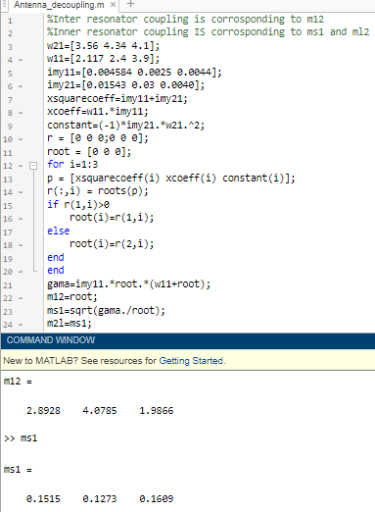

## Results are obvious as we decrease inter resonator distance m₁₂ increases and if we decrease inner resonator distance ms₁ increases.

# Conclusion

This paper presented a new technique for isolating two antennas. Focus of this paper goes in relating physical dimensions of CRDN with it’s electrical equivalents which is made possible through Y parameter of antennas. After fetching coupling elements such as m₂₁, m₁₁, m₂₂, mₛ₁, mₗ₂ from Y matrix for all the designs physical dimensions seems relatable with electrical equivalents. As inter-resonator distance keeps decreasing the coupling element m₂₁ also keeps increasing and as inner resonator distance keeps decreasing the coupling element mₛ₁ and mₗ₂ also keep increasing.

|  |  |
| --- | --- |
|  |  |

##### References

1. L.Y. Zhao, L.K. Yeung, K.L. Wu, "A coupled resonator decoupling network for two-element compact antenna arrays in mobile terminals", *IEEE Trans. Antennas Propag.*, vol. 62, no. 5, pp. 2767-2776, 2014.
2. R.Vaughan and J. B. Andersen, Channels, Propagation and Antennas for Mobile Communications. London, U.K.: The Institute of Electrical Engineers, 2003
3. M. A. Jensen and J. W.Wallace, “A review of antennas and propagation for MIMO wireless communications,” IEEE Trans. Antennas Propag., vol., 52, no. 11, pp. 2810–2824, Nov. 2004
4. C. B. Dietrich, Jr., K. Dietze, J. R. Nealy, and W. L. Stutzman, “Spatial, polarization, and pattern diversity for wireless handheld terminals,” IEEE Trans. Antennas Propag., vol. 49, no. 9, pp. 1271–1281, 2001.
5. M. Pelosi, M. B. Knudsen, and G. F. Pedersen, “Multiple antenna systems with inherently decoupled radiators,” IEEE Trans. Antennas Propag., vol. 60, pp. 503–515, Feb. 2012.
6. ]Z. N. Chen, X. N. Low, and T. S. P. See, “Analysis and optimization of compact suspended plate MIMO antennas,” IEEE Trans. Antennas Propag., vol. 59, no. 1, pp. 263–270, Jan. 2011.
7. G. L. Stuber, J. R. Barry, S. W. McLaughlin, Y. Li, M. A. Ingram, and T. G. Pratt, “Broadband MIMO-OFDM wireless communications,” Proc. IEEE, vol. 92, no. 2, pp. 271–294, Feb. 2004
8. M. A. Jensen and J. W.Wallace, “A review of antennas and propagation for MIMO wireless communications,” IEEE Trans. Antennas Propag., vol., 52, no. 11, pp. 2810–2824, Nov. 2004
9. [Online].Available: http://www.qualcomm.com/media/documents/files/lte-advanced-an-e volution-built-for-the-long-haul.pdf
10. A. Paulraj, R. Nabar, and D. Gore, Introduction to Space-Time Wireless Communications. Cambridge, U.K.: Cambridge Univ. Press, 2003.